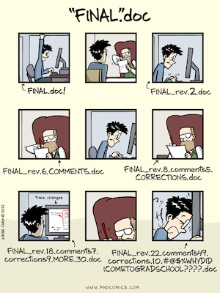

**Version Control Systems**

* A software which helps in keeping a track of modifications done in the code.

**Importance:**

* **Tracks Changes** – Keeps a history of modifications, allowing rollback if needed.
* **Enables Collaboration** – Multiple developers can work simultaneously without conflicts.
* **Ensures Code Integrity** – Prevents accidental overwrites and loss of work.
* **Supports Experimentation** – Branching allows safe testing of new features.
* **Maintains Documentation** – Provides a clear history of who changed what and why.
* **Facilitates Deployment** – Helps manage releases and rollbacks efficiently.

**Key Terms:**

* **Repository (Repo)** – A storage location for code and its history.
* **Commit** – A snapshot of changes saved in the version history.
* **Branch** – A separate line of development that allows independent changes.
* **Merge** – Combining changes from different branches.
* **Pull Request (PR) / Merge Request (MR)** – A request to merge changes into another branch.
* **Clone** – A local copy of a remote repository.
* **Push** – Sending local commits to a remote repository.
* **Pull** / **Fetch** – Retrieving updates from a remote repository.
* **Conflict** – A situation when changes in different branches affect the same part of code.
* **Tag** – A reference to a specific commit, often used for version releases.
* **Revert** – Undoing changes from a previous commit.
* **Stash** – Temporarily saving uncommitted changes without committing them.
* **Checkout** – Switching between different branches or commits.
* **Diff** – Comparing changes between different commits or branches.
* **Blame** – Identifying who made specific changes to a file.

**Types of Version Control Systems:**

* Local Version Control Systems
* Centralized Version Control Systems

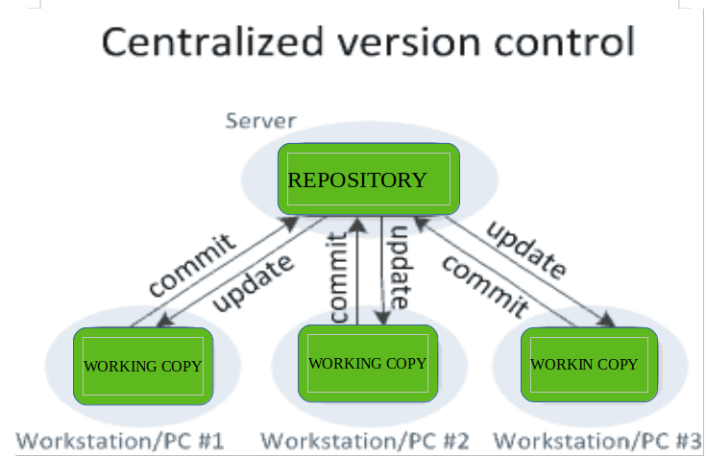

* Distributed Version Control Systems

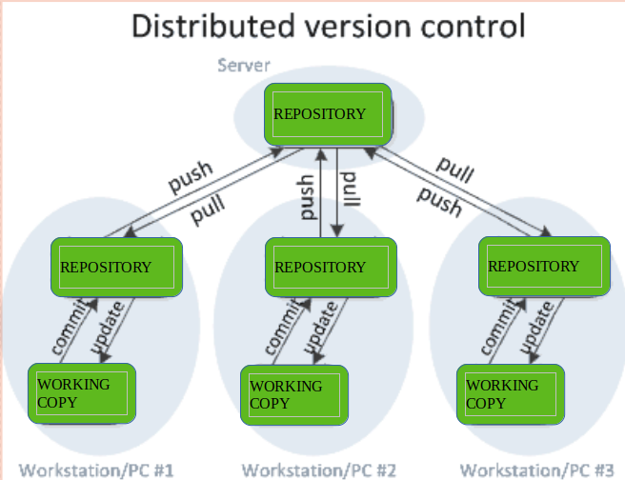

**Activity:**

1. Paper based version control - conceptual
2. Offline folder: Saving files with version names
3. Google Drive/ OneDrive - demo
4. Github/ Gitlab – once you get legal access 😉